

AP® Physics C
1989 Free response Questions

The materials included in these files are intended for use by AP teachers for course and exam preparation in the classroom; permission for any other use must be sought from the Advanced Placement Program®. Teachers may reproduce them, in whole or in part, in limited quantities, for face-to-face teaching purposes but may not mass distribute the materials, electronically or otherwise. These materials and any copies made of them may not be resold, and the copyright notices must be retained as they appear here. This permission does not apply to any third-party copyrights contained herein.

These materials were produced by Educational Testing Service® (ETS®), which develops and administers the examinations of the Advanced Placement
Program for the College Board. The College Board and Educational Testing Service (ETS) are dedicated to the principle of equal opportunity, and their
programs, services, and employment policies are guided by that principle.

The College Board is a national nonprofit membership association dedicated to preparing, inspiring, and connecting students to college and opportunity.
Founded in 1900, the association is composed of more than 4,200 schools, colleges, universities, and other educational organizations. Each year, the
College Board serves over three million students and their parents, 22,000 high schools, and 3,500 colleges, through major programs and services in
college admission, guidance, assessment, financial aid, enrollment, and teaching and learning. Among its best-known programs are the SAT®, the
PSAT/NMSQT®, and the Advanced Placement Program® (AP®). The College Board is committed to the principles of equity and
excellence, and that commitment is embodied in all of its programs, services, activities, and concerns.

APIEL is a trademark owned by the College Entrance Examination Board. PSAT/NMSQT is a registered trademark jointly owned by the College Entrance Examination Board and the National Merit Scholarship Corporation. Educational Testing Service and ETS are registered trademarks of Educational Testing Service.
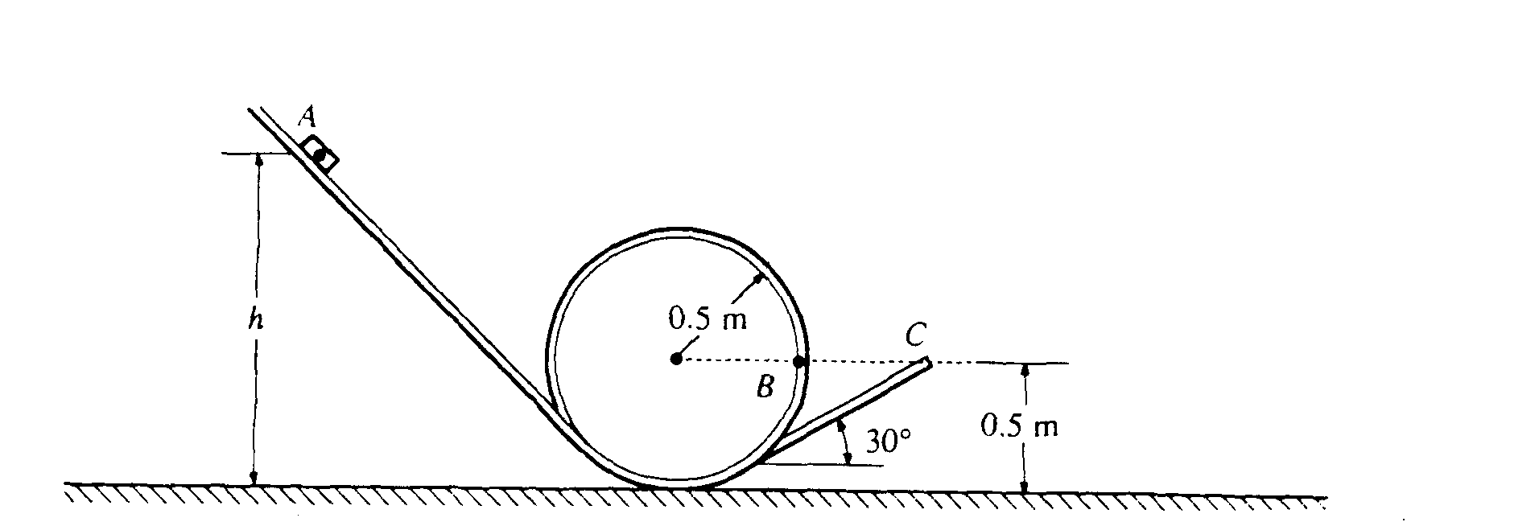
1989M1. A 0.1-kilogram block is released from rest at point A as shown above, a vertical distance h above the ground. It slides down an inclined track, around a circular loop of radius 0.5 meter, then up another incline that forms an angle of 30° with the horizontal. The block slides off the track with a speed of 4 m/s at point C, which is a height of 0.5 meter above the ground. Assume the entire track to be frictionless and air resistance to be negligible.
a. Determine the height h .
b. On the figure below, draw and label all the forces acting on the block when it is at point B. which is 0.5 meter above the ground.

c. Determine the magnitude of the force exerted by the track on the block when it is at point B.
d. Determine the maximum height above the ground attained by the block after it leaves the track.
e. Another track that has the same configuration, but is NOT frictionless, is used. With this track it is found that if the block is to reach point C with a speed of 4 m/s, the height h must be 2 meters. Determine the work done by the frictional force.
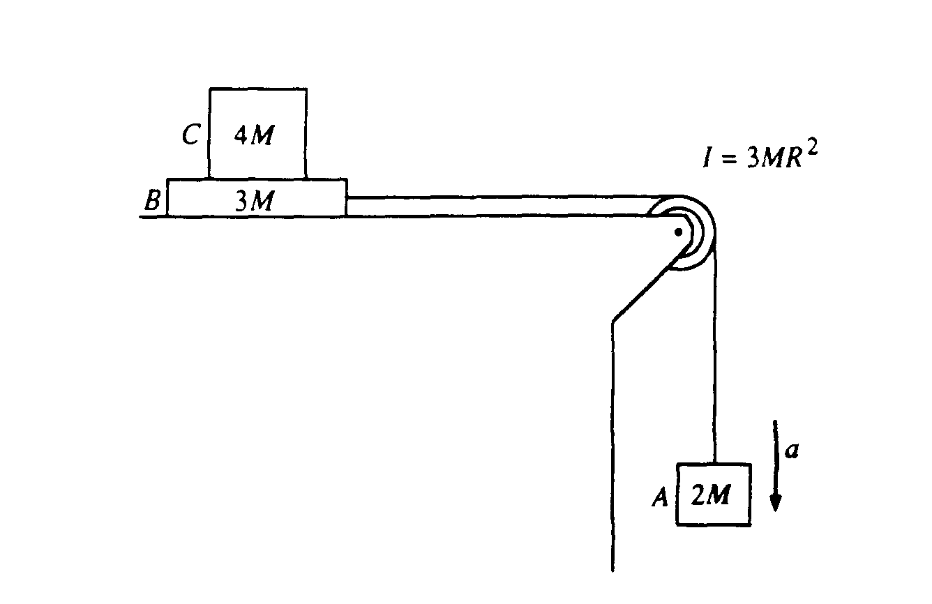

1989M2. Block A of mass 2M hangs from a cord that passes over a pulley and is connected to block B of mass 3M that is free to move on a frictionless horizontal surface, as shown above. The pulley is a disk with frictionless bearings, having a radius R and moment of inertia 3MR². Block C of mass 4M is on top of block B. The surface between blocks B and C is NOT frictionless. Shortly after the system is released from rest, block A moves with a downward acceleration a, and the two blocks on the table move relative to each other.

In terms of M, g, and a, determine the
a. tension T_{v} in the vertical section of the cord
b. tension T_{h} in the horizontal section of the cord

If a = 2 meters per second squared, determine the
c. coefficient of kinetic friction between blocks B and C
d. acceleration of block C

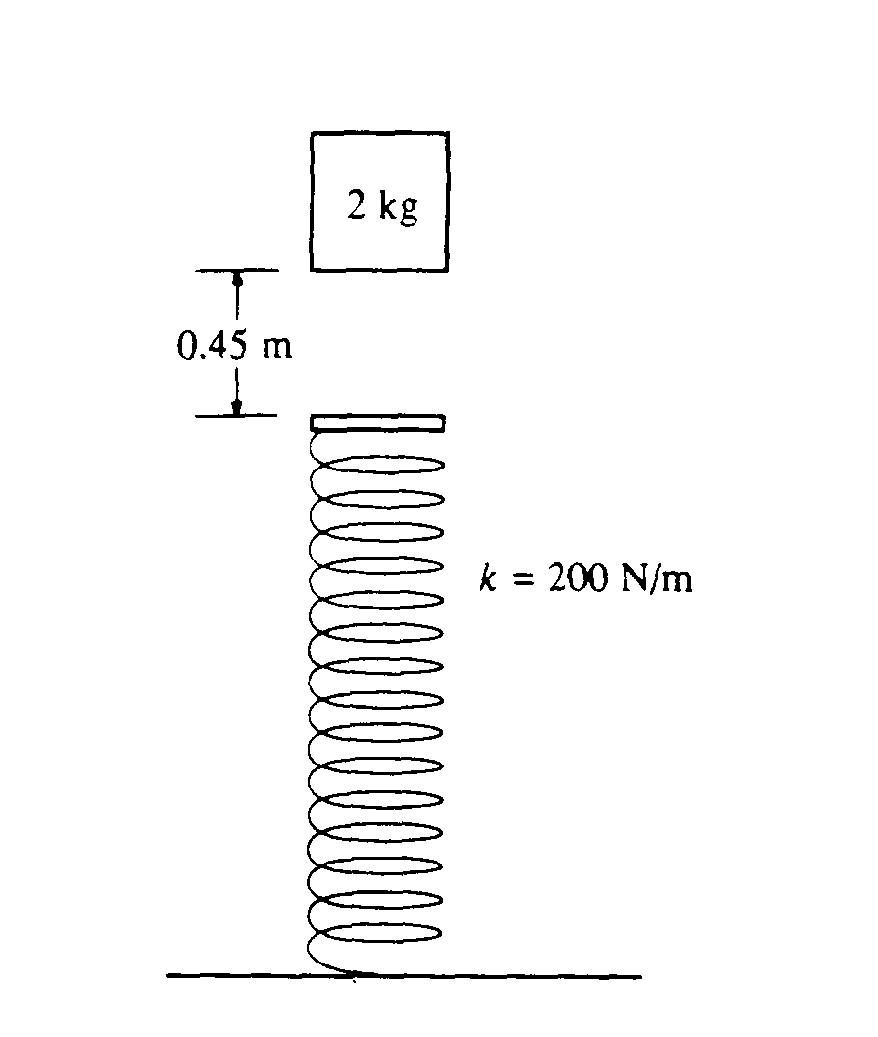
1989M3. A 2-kilogram block is dropped from a height of 0.45 meter above an uncompressed spring, as shown above. The spring has an elastic constant of 200 newtons per meter and negligible mass. The block strikes the end of the spring and sticks to it.
a. Determine the speed of the block at the instant it hits the end of the spring.
b. Determine the period of the simple harmonic motion that ensues.
c. Determine the distance that the spring is compressed at the instant the speed of the block is maximum.
d. Determine the maximum compression of the spring.
e. Determine the amplitude of the simple harmonic motion.

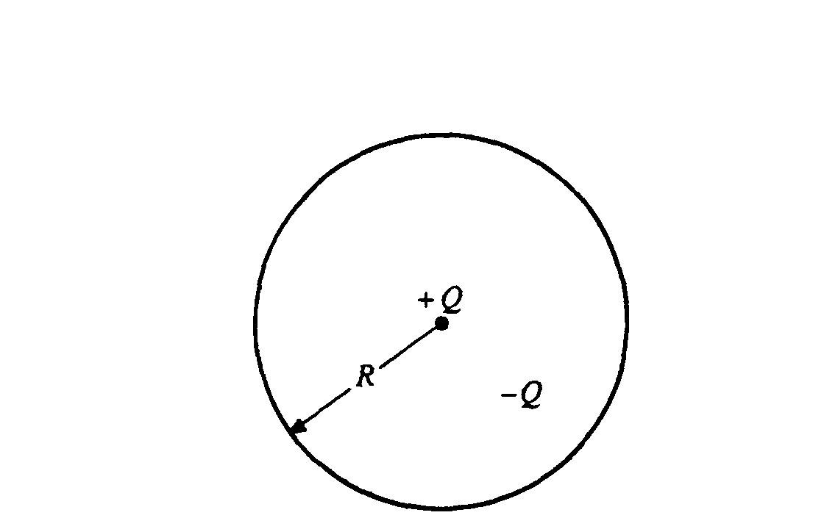
1989E1. A negative charge - Q is uniformly distributed throughout the spherical volume of radius R shown above. A positive point charge + Q is at the center of the sphere. Determine each of the following in terms of the quantities given and fundamental constants.
a. The electric field E outside the sphere at a distance r > R from the center
b. The electric potential V outside the sphere at a distance r > R from the center
c. The electric field inside the sphere at a distance r < R from the center
d. The electric potential inside the sphere at a distance r < R from the center

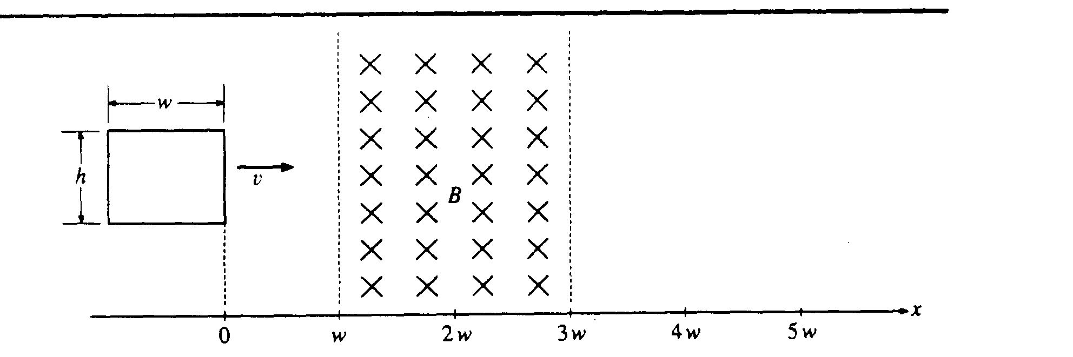
1989E2. A rectangular loop of wire of resistance R and dimensions h and w moves with a constant speed v toward and through a region containing a uniform magnetic field of strength B directed into the plane of the page. The region has a width of w as shown above.

a. For the interval after the right-hand edge of the loop has entered the field but before the left-hand side of the loop has reached the field, determine each of the following in terms of B, w, h, v, and R.
i. The magnitude of the induced current in the loop
ii. The magnitude of the applied force required to move the loop at constant speed
b. On the axes below, plot the following as functions of position x of the right edge of the loop shown above.
i. The induced current I in the loop
ii. The applied force F required to keep the loop moving at constant speed

Let counterclockwise current be positive, clockwise current be negative, forces to the right be positive, and forces to the left be negative. The graphs should begin with the loop in the position shown (x = 0) and continue until the right edge of the loop is a distance 2w to the right of the region containing the field (x = 5w).
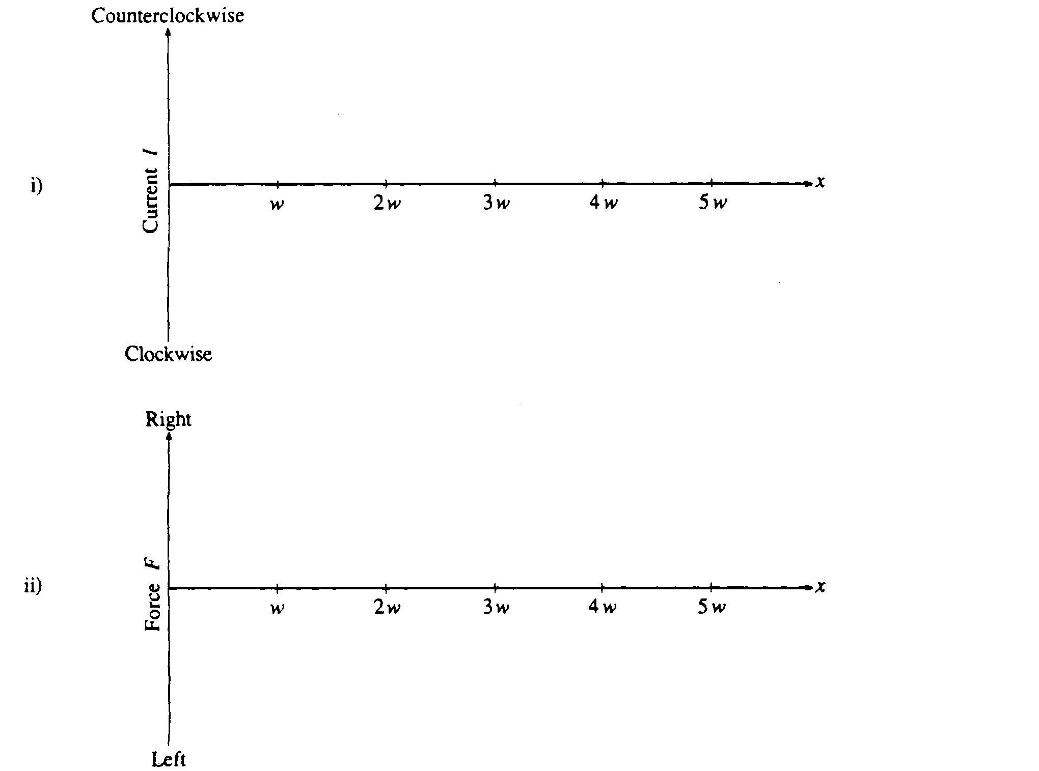

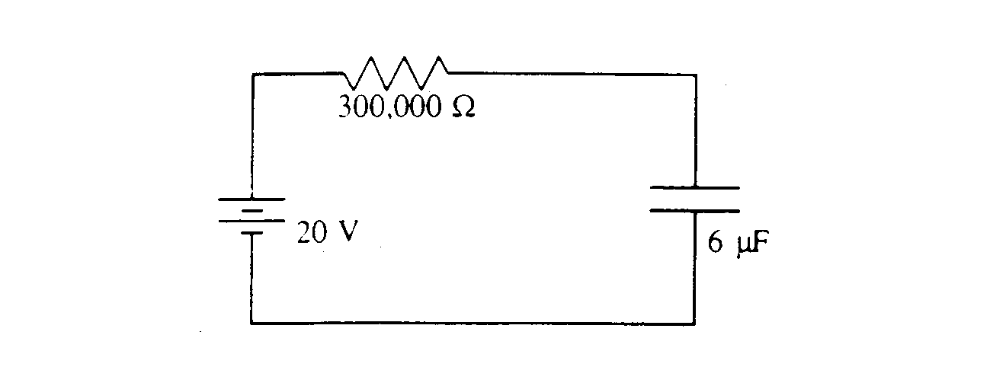
1989E3. A battery with an emf of 20 volts is connected in series with a resistor of 300,000 ohms and an air-filled parallel-plate capacitor of capacitance 6 microfarads.
a. Determine the energy stored in the capacitor when it is fully charged.

The spacing between the capacitor plates is suddenly increased (in a time short compared to the time constant of the circuit) to four times its original value.
b. Determine the work that must be done in increasing the spacing in this fashion.
c. Determine the current in the resistor immediately after the spacing is increased.

After a long time. the circuit reaches a new static state.
d. Determine the total charge that has passed through the battery.
e. Determine the energy that has been added to the battery.

